Project Design Phase-II
Data Flow Diagram & User Stories

Date | 27 August 2026
Project Name | Employee Raise Issue
Maximum Marks | 4 Marks

Data Flow Diagrams:
A Data Flow Diagram (DFD) is a graphical representation of how information moves through the Employee Raise Issue system. It illustrates how an employee submits an issue, how the system processes and stores the issue details, and how HR/Admin reviews and manages the reported issue.
In the Employee Raise Issue system, the DFD represents the interaction between Employee, System, HR/Admin, Concerned Department/Assigned Staff, Issue Database, and Notification Service. It shows the flow of issue details from the employee to the system, the storage of issue information, assignment and resolution of issues, and the notification sent to the employee.
The diagram also helps to understand how issue information is created, updated, stored, retrieved, and communicated throughout the issue-resolution process. It provides a clear overview of the system and helps identify the responsibilities of each user and component involved in handling employee issues.

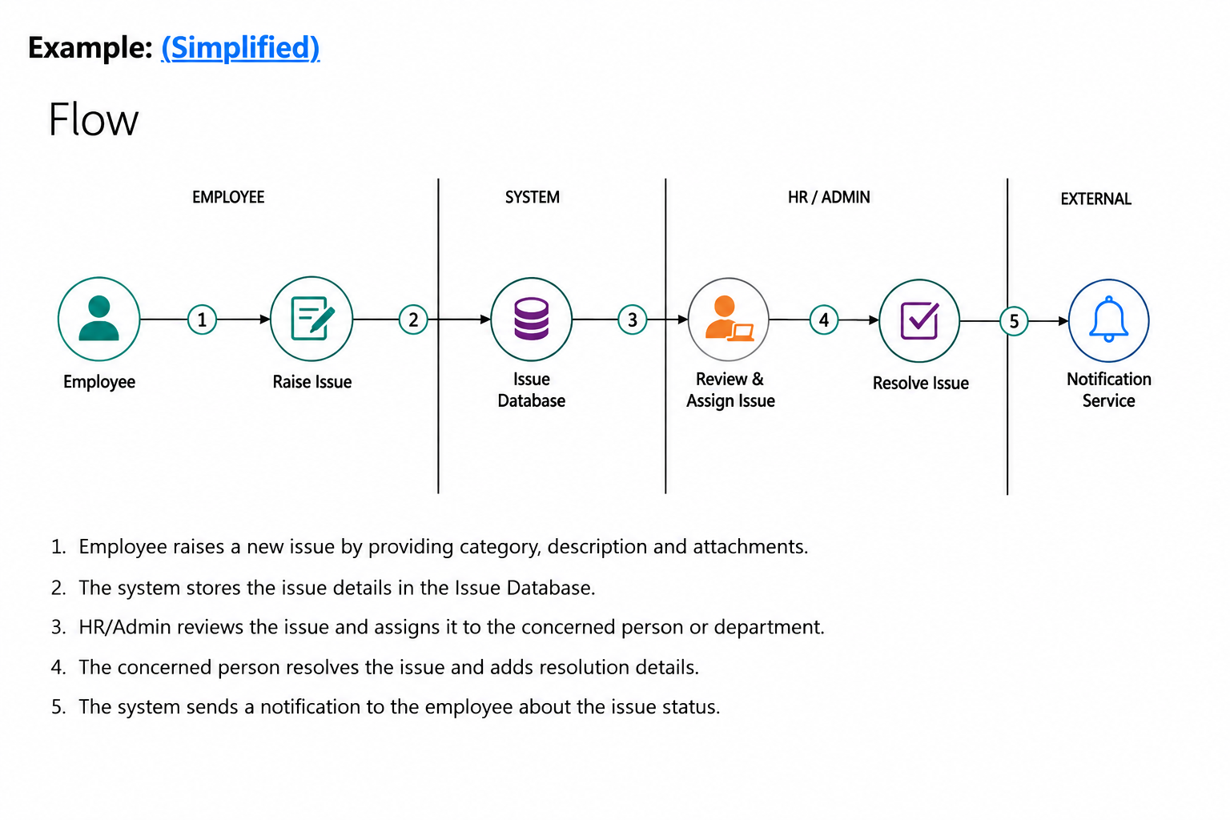

User Stories
Use the below template to list all the user stories for the product.
User Type | Functional Requirement (Epic) | User Story Number | User Story / Task | Acceptance Criteria | Priority | Release
Employee | Employee Registration & Login | USN-1 | As an employee, I can register for the application by entering my name, employee ID, email, password, and other required details. | I can successfully register and access my account/dashboard. | High | Sprint-1
Employee | Employee Registration & Login | USN-2 | As an employee, I can log into the application using my employee ID/email and password. | I can successfully log in and access the employee dashboard with valid credentials. | High | Sprint-1
Employee | Raise an Issue | USN-3 | As an employee, I can raise a new issue by selecting an issue category and entering the issue description. | I can submit an issue successfully with all mandatory information. | High | Sprint-1
Employee | Raise an Issue | USN-4 | As an employee, I can attach supporting documents or images while raising an issue. | I can upload an attachment and it is saved with the submitted issue. | Medium | Sprint-2
Employee | Issue Management | USN-5 | As an employee, I can view the issues that I have previously raised. | I can view my submitted issues with their category, description, date, and status. | High | Sprint-2
Employee | Issue Management | USN-6 | As an employee, I can track the current status of my raised issue. | I can see statuses such as Submitted, Under Review, Assigned, In Progress, Resolved, and Closed. | High | Sprint-2
Employee | Notifications & Communication | USN-7 | As an employee, I can receive notifications when the status of my issue is updated. | I receive a notification whenever my issue is assigned, updated, or resolved. | Medium | Sprint-3
Employee | Notifications & Communication | USN-8 | As an employee, I can view the comments and resolution details provided for my issue. | I can view HR/Admin comments and the final resolution details. | Medium | Sprint-3
HR / Admin | Issue Management | USN-9 | As an HR/Admin, I can view all issues raised by employees. | I can view employee issue details, category, priority, and current status. | High | Sprint-1
HR / Admin | Issue Assignment & Resolution | USN-10 | As an HR/Admin, I can review an employee issue and assign it to the concerned department or staff member. | The issue can be assigned successfully and the assignment details are recorded. | High | Sprint-2
HR / Admin | Issue Assignment & Resolution | USN-11 | As an HR/Admin, I can update the status of an issue and add comments or resolution details. | The updated status and resolution details are saved and visible to the employee. | High | Sprint-2
Concerned Department / Staff | Issue Assignment & Resolution | USN-12 | As assigned staff, I can view the issues assigned to me and work on them. | I can view the assigned issue details and take appropriate action. | High | Sprint-2
Concerned Department / Staff | Issue Assignment & Resolution | USN-13 | As assigned staff, I can provide resolution details and update the issue status. | Resolution details are saved and the issue status is updated successfully. | High | Sprint-3
HR / Admin | Dashboard & Reports | USN-14 | As an HR/Admin, I can view a dashboard containing pending, assigned, in-progress, and resolved issues. | Dashboard displays accurate issue counts and statuses. | Medium | Sprint-3
HR / Admin | Dashboard & Reports | USN-15 | As an HR/Admin, I can filter issues based on category, department, priority, and status. | I can filter and find the required employee issues easily. | Low | Sprint-3

